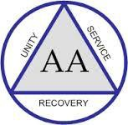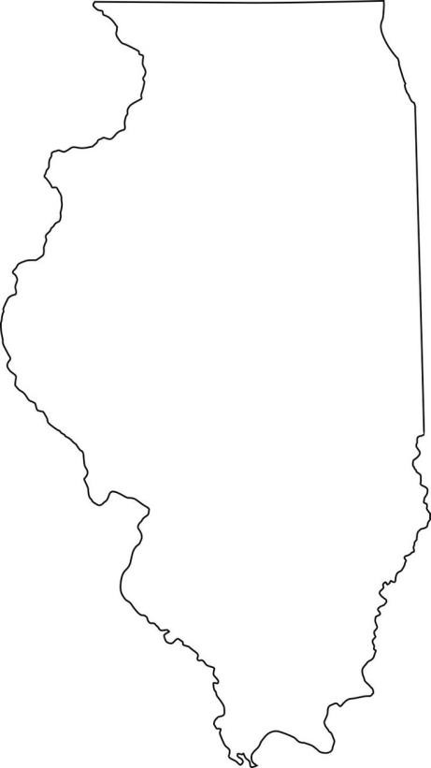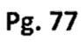2016 Illinois State Conference
& East Central Regional Conference
Hosted by Northern Illinois Area 20 Districts 10, 11, and 28

REGISTER ONLINE NOW
www.aailcon.org
August 12-14th, 2016

AA SPEAKERS
Madeleine P. of Happy Valley, Oregon
Laurie H. of Oak Lawn, Illinois
St. Charles

GSO Staff Member
Jeff W.

Online registration
closes at 12am on 8/5 On-site registration begins at 2pm on 8/12
Reserve a room: http://bit.ly/ilcon2016 Room Rate: $109.00
Mention 2016 IL State Conference
when making reservations to obtain this rate
Questions? Contact Us!
Chair: Carl T. 847-736-8064
Registration: Dana T. 847-322-5256 Or visit our website: www.aailcon.org
East Central Regional Trustee
Bill F. of Marietta, Ohio
AL-ANON SPEAKER
David E. of Chicago, Illinois

Delegate Sessions Literature Archives Workshops Alcathons
Panels Dance Fellowship Fun
Pheasant Run
Resort
4051 E. Main St.
St. Charles, IL, 60174 630-584-6300

(1) One person per registration form. PLEASE PRINT.
First Name: Last Name: Address: City/State: Zip: Email: Phone: _ Please specify:   AA   Alanon   Guest
- Registration $25  Friday Night Ice-Cream Social $5  Saturday Boxed Lunch $10
- Banquet Dinner $35 (Choose One)  Chicken  Beef  Vegetarian
Total: $
Mailing Address: 2016 IL State Conference PO Box 6689, Libertyville, IL 60048
Make Checks Payable to: 2016 IL State Conference Deadline for mail-in registration- 7/22/2016
- I would like someone to contact me about special needs /disability services while at the conference.
- I would like a Spanish interpreter
(Please contact us by 7/29/16 if you have special needs requirements while at the conference)
Note: All participants must be registered and their registration badges must be worn at all events during the conference.

